A000-Eur-Danube Rider Votive Plaque-Sol Invictus-Corinthian Columns-Lead-3rd c CE

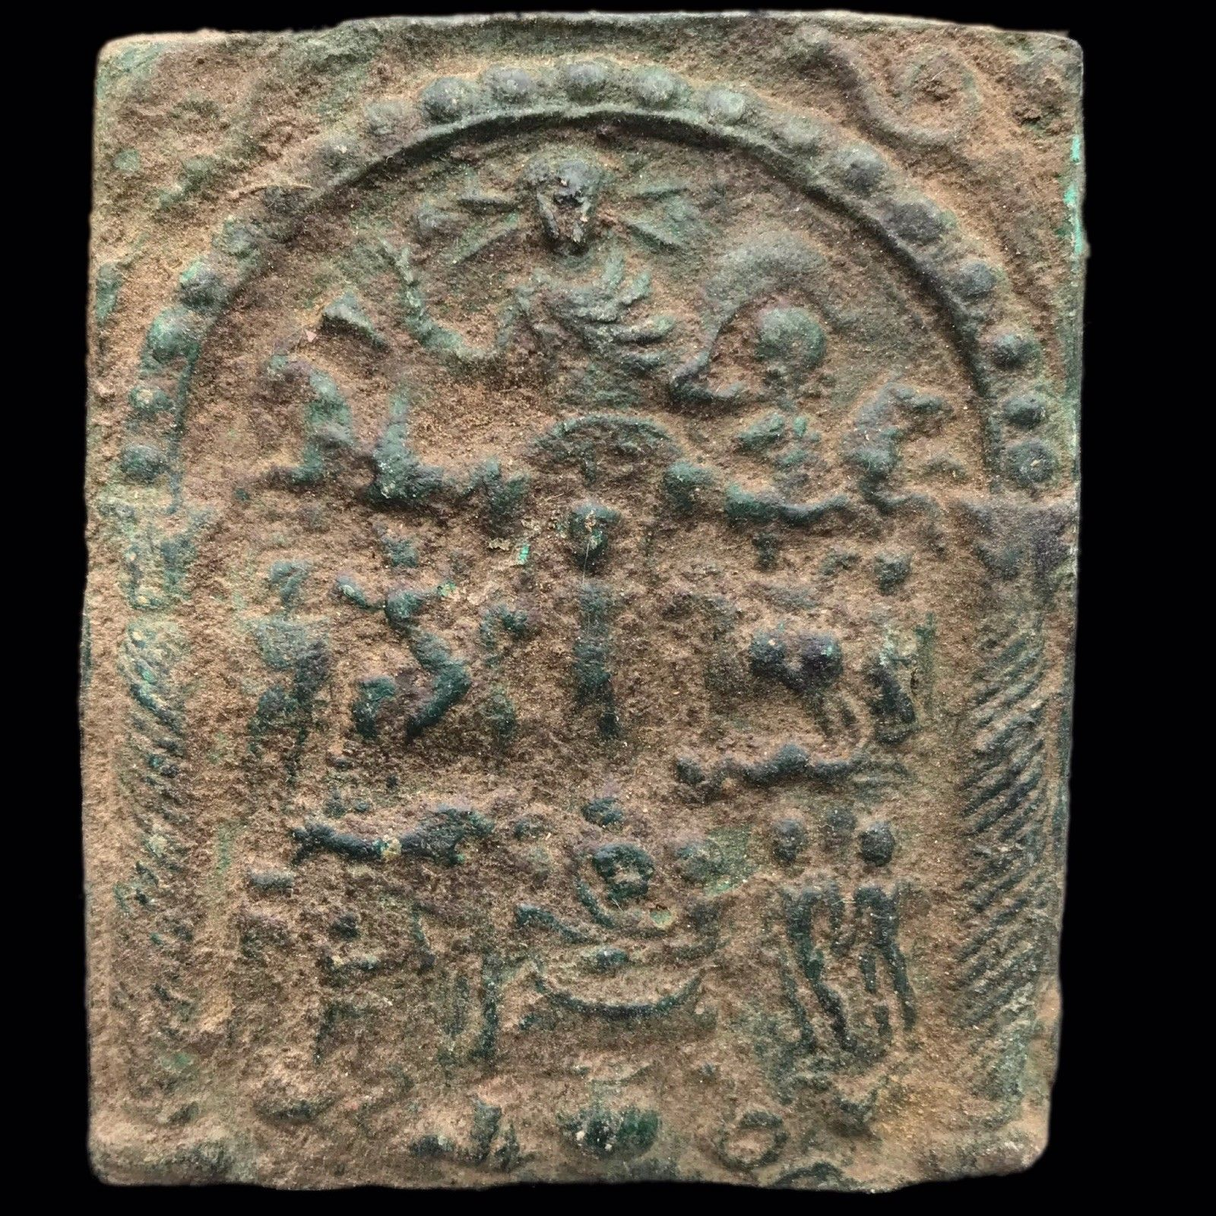

**Case No.: 3**

**Accession No. A000**

**Formal Label:** A000-Eur-Danube Rider Votive Plaque-3rd c CE

**Display Description:**

The plaque contains a complex iconography of divine figures and symbols, probably associated with Thracian or Dacian beliefs of the Lower Danube region. Presiding over the whole scene is Sol Invictus (the invicible sun-god) in a quadriga (four-horse chariot). His cult originated in the Near East and gained increasing influence under imperial patronage during the third century CE when On 25 December 274 AD the [Roman emperor](https://en.wikipedia.org/wiki/Roman_emperor) [Aurelian](https://en.wikipedia.org/wiki/Aurelian) made it an official [cult](https://en.wikipedia.org/wiki/Cult_(religious_practice)) alongside the traditional Roman cults.. These votive plaques encompass Thracian and Danubian Rider iconographies, as well as the iconography of the Celtic Goddess Epona, who has a special equestrian apotropaic rôle that was championed by the Roman cavalry. The apotropaic theme is further adumbrated in the top corners of the plaque with two coiling snakes, perhaps relating to the healing powers of Asclepius and the serpents that were let loose in the abata or hospitals to attack vermin and to lick the bodies of the patients at night while the residents were sleeping. Asclepius’ hospital or abaton was brought to Rome’s Tiber island from Pergamum by ship in the fourth century BCE during a disease outbeak.

This rectangular, cast-lead plaque is framed by two Corinthian columns framing an arch suggestive of a cultic sanctuary. In the first register within the sanctuary Sol, crowned with solar rays, is shown in his quadriga or four-horse chariot. He holds a globe in his left hand. Above the horses are the morning star and the evening star.

Central in the second register is a woman or goddess. She is lifting her garment, forming a sack to feed of the horses. On either side of her we see the typical horsemen, greeting the goddess. The horses step on a fish (on the proper right hand side of the central figure) and a man lying on the ground (on her proper left-hand side).

The third register contains in the middle a couple of men (possibly priests, because on many of these plaques they are depicted boldly), grouped around a table with a fish (which has been explained as offertory meal); there are other figures in the same register.

In the fourth register we see a tripod table with fish on it, a kantharos (a symbol for water), a lion (a symbol for fire), a snake (a symbol for the earth) and a rooster (a symbol for the air).

**LC Classification:**

**Date or Time Horizon:** Circa 2nd-4th century C.E.

**Geographical Area:**

**Map:**

**GPS coordinates:**

**Cultural Affiliation:**

**Medium: Lead**

**Dimensions:** 92x77x3mm, rectangular in shape and cast in relief.

**Weight:**

**Condition: original,** Minor damage to left bottom of border, otherwise well preserved.

**Provenance:** Collection of Professor Rudolf Franz Ertl. He published part of his collection of cult plaques in the book Donaureiter – Bleivotivtafeln. Versuch einer Typologie (Wien, 1996). Reinhard Dollinger

45 Great Cumberland Place

W1H7DL Marble Arch, London

Großbritannien

**Discussion:**

The protector of horses, mules, and cavalry, Epona was one of the only non-Roman goddesses to have been wholly adopted by the Roman Empire.  Often depicted astride a horse, Epona resonated in the forces of the Roman cavalry as an inspiration and guide through even the darkest of battles, and she remained one of their most worshipped goddesses between the first and third centuries AD.

Interestingly, Epona was also seen as a goddess of fertility, accompanied in many of her depictions by grain or a cornucopia. Coupled with the worship of her equine prowess in the military, it is evident she was seen both in Gaulish and Roman cultures as a deity of prosperity within the equestrian home and on the battlefield.

It has also been argued that Epona served as an escort for souls into the afterlife. The presence of a statue of Epona in her horse form [**was found in the grave of a young girl**](http://www.huntspost.co.uk/news/the-roman-burial-that-offers-a-rare-glimpse-into-past-of-huntingdonshire-town-1-5301779)who died in the 2nd century and seems to support this notion. That burial was discovered in Godmanchester (Roman Durovigutum), in the Huntingdonshire district of Cambridgeshire, England.

Originally from Gaul, Epona was worshipped in Britain throughout the Iron Age, coming to the continent during the time of the Romans. As far as modern scholarship can tell, her worship extended as far north as the Strathclyde Region in Scotland, with depictions of her found on the Roman wall forts of Hadrian and Antonine, but her veneration stretched no further than the farthest reach of the Empire.  There is no evidence of Epona in the Near East - an understandable lack, as the Romans were never able to conquer or occupy the Persian Empire. It is unknown from where, exactly, Epona originated but she was prevalent throughout the tribes of the Celts and quickly became widespread throughout the Empire as well.

Epona made her way to Rome through the aid of the Roman military. The Roman cavalry was formed of foreign auxiliaries from groups and tribes conquered by the Empire.  Though many of these men were not citizens, citizenship could be attained after a certain number of years in the military, which meant that the Roman forces were exposed to foreign religions quite often and for long periods of time.  Even though Gauls were not one of the prominent groups in the cavalry, Epona was introduced to this amalgamation of men during their time fighting in Gaul. With so many men from so many different cultures gathered together with such a prestigious equestrian duty to perform, it is natural that they would desire their own religious spirit or guide. Upon discovering her impression in Gaul, Epona became the perfect choice.

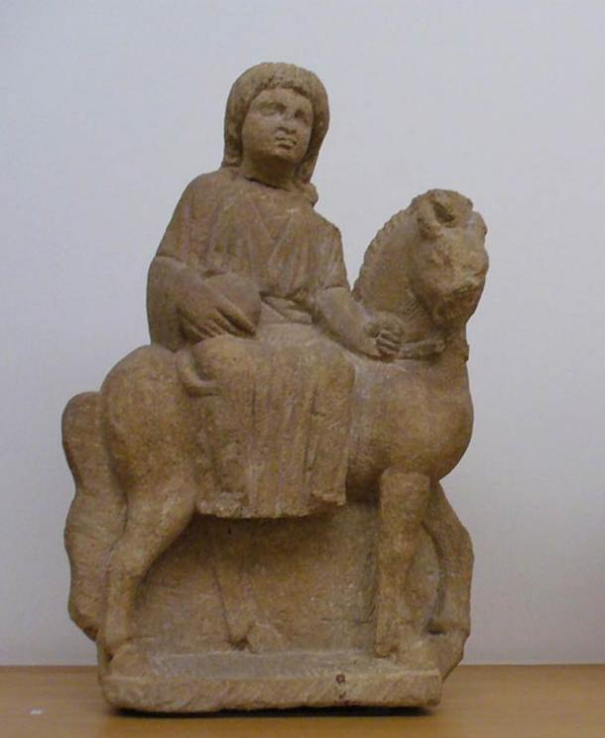

Small sculpture of the Roman/Celtic goddess Epona, third century CE. [**Public Domain**](https://commons.wikimedia.org/wiki/File:Luxembourg_MNHA_265_Epona_provenance_incertaine.jpg)

Epona was one of the gods of the Augustus Equites singulares, who were recruited among cavalry units located in the regions on the Rhine and the Danube. Epona's distribution throughout the realm was greatly aided by the fact that the Romans were already a religiously tolerant culture. Many gods of Gaul had been brought into the Empire by marrying Roman gods (as was the case with Mercury and Rosmerta) or by re-appropriating their names and affiliations to align with pre-existing Roman gods.

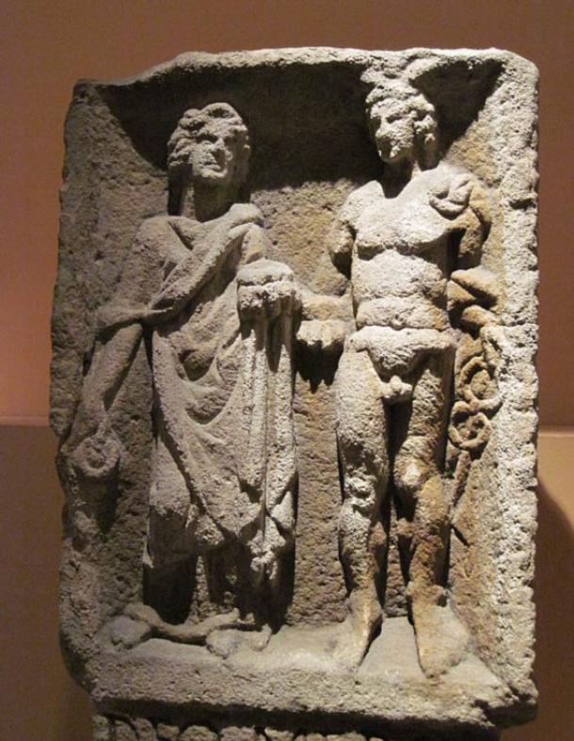

Relief of Mercury and Rosmerta from Eisenberg in present-day Rhineland-Palatinate. Wikimedia, ( ***[CC BY-SA 3.0)](https://commons.wikimedia.org/wiki/File:Mercurius_Rosmerta_HistMusPfalz_3513.jpg" \t "_blank)***

Epona is unique in that she was not renamed or married to a Roman husband—she came to Rome as herself and blended quite smoothly into the Roman military.  She is the only known Celtic deity to have been embraced in her original form by the Empire, with little adjustment made to her list of attributes. Her likeability spread outside of the military and into the homes of the Roman people as well.

The countryside of Rome consisted of widespread farmland, an environment that led to a need for a goddess who could protect and look over the stables and horses of the common people outside of the military.  As Epona was introduced into the city of Rome, her name and image spread like wildfire. Farmers, stable hands, grooms, drivers, and so many other ordinary people who interacted with horses and mules on a day to day basis welcomed Epona into their own lives and homes, and worshipped her as frequently as the Roman military She was revered in various ways throughout the region, depending on whether the worshipper was military or civilian. The cavalry erected small shrines wherever they went, which was one of the reasons why her cult was so widespread.  They sacrificed to her before important battles and wrote numerous vows and inscriptions to her.

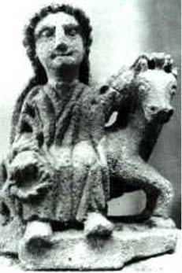

Small Epona sculpture from Auxois, France. [**Public Domain**](https://commons.wikimedia.org/wiki/File:Epona_Auxois.jpg)

In the home, there were more diminutive devices for her worship—tokens and flowers were laid out to her in countless equine locations, and small statues were often erected in houses and stables. It was on these statues that cornucopias were depicted, revealing the desire of the Roman people for her to bring fertility to their stables and strong mares to their herds. A good horse or donkey was an important source of transportation in ancient Rome—among the elite in particular, a strong horse was a valuable source of prestige.

Statues depicted Epona in three varying forms: astride her horse, as an imperial goddess, or riding upon a cart. It should be noted that in the Gaulish tradition, it was not customary to portray the gods in human form but rather in the form of an animal, plant, or other appropriate emblem of their worship.  Previous to the Romans, Epona was merely the image of a horse or mule. Upon coming to Rome, she was altered to appear as the Roman gods did, thus in the three aforementioned ways.

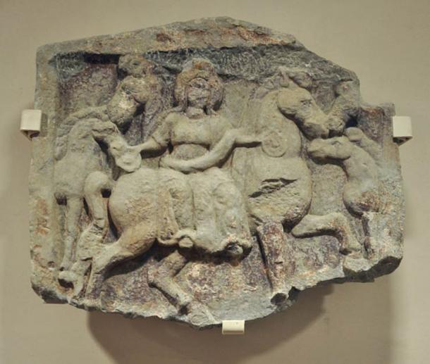

A relief depicting Epona and horses. Vorarlberg Museum, Bregenz, Austria. [**Public Domain**](https://commons.wikimedia.org/wiki/File:Epona-Relief_VLM.jpg)

Riding was the most common way in which Epona was shown, always sidesaddle and often with a cornucopia in her hands signifying both her fertility and that of the horses under her guidance. The imperial image portrays Epona in a more regal fashion, often standing between two to four horses and either standing or seated on a throne. Images such as these were undoubtedly inspired by the art of the Roman emperor and meant to show Epona as the sovereign of both equestrians and their owners.  The cart image has the least circulation and it shows Epona in a cart or chariot lead by horses. Interestingly, these images can be seen as a servile relationship between the goddess and her creatures which may (though there is little evidence) be the reason such depictions are few and far between.

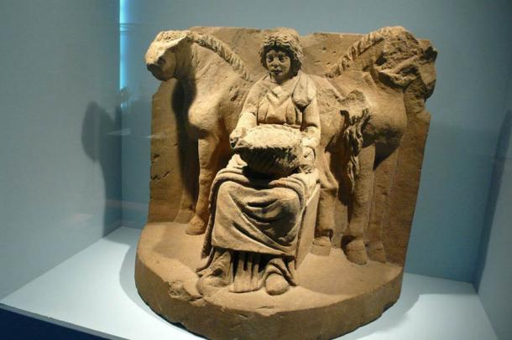

The motif of the "Lady of the Animals" lives on this religious depiction. Flanked by two horses, Epona is shown sitting on a throne holding a fruit basket on her lap. Circa 200 AD. Wikimedia, ( **[CC BY-SA 2.0](https://commons.wikimedia.org/wiki/Category:Epona" \l "mediaviewer/File:Epona.jpg" \t "_blank)**)

Epona is easily one of the most interesting goddesses assimilated into the Roman Empire. The apparent seamlessness and ease of her transition is only one of the reasons why she was such a fascinating addition to the culture of the Romans. She remains an example of the ways in which foreign gods were adopted into the Empire and the reasons for these adoptions. Furthermore, her fusion into the Empire allowed for rare extensive knowledge of her original Gaulish character and her subsequent alterations to be passed down for modern research.

Featured image: A relief of Epona, flanked by two pairs of horses, from Roman Macedonia, foruth century C.E. Wikimedia, ( **[CC BY-SA 3.0](https://commons.wikimedia.org/wiki/File:Epona_Salonica601_ArchMus.jpg" \t "_blank)**)

By [**Ryan Stone**](https://www.ancient-origins.net/users/ryan-stone)

**References:**

Adkins, L. and R. Adkins.1998.  Handbook to life in ancient R Rome. Oxford:Oxford University Press.

Anon. 2015. "Epona Depictions." Epona.net- a Scholarly Resource. January 1, 2004. Accessed January 1, 2015. [**http://www.epona.net/depictions.html**](http://www.epona.net/depictions.html).

Bianconi, G. L. (1789) Descrizione dei Circhi particolarmente di quello di Caracalla e dei giuochi in essi celebrati.

Cattaneo, G. (1819). Equejade, monumento antico de bronzo del Museo nazionale ungherese considerato ne' suoi rapporti coll' antichità figurata. Milano, Imp. Regia stamperia. Fig. 3

Chevallier, Raymond (1998) *Voyages et Déplacements dans l'Empire Romain*. Armand Collin, Paris.

Collingwood, R.G.; Wright, R.P. 1965. The Roman Inscriptions of Britain (RIB) Oxford: Clarendon Press.

Dorow, W. (1826) *Opferstätten und Grabhügel der Germanen und Römer am Rhein*. Wiesbaden, **II**, p.28 and plate XIV

Ertl. Rudolf Franz 1996. Donaureiter – Bleivotivtafeln. Versuch einer Typologie. Wien.

Espérandieu, É. (1907) Recueil général des bas-reliefs de la Gaule romaine. Paris, Imprimerie nationale.

Hettner, F. (1876) *Katalog des Königlich-Rheinischen Museums Vaterländischer Alterthümer bei der Universität Bonn*. Bonn, p.79, #216

Irby-Massie, G. L. 1999. Military religion in Roman Britain. Leiden: Brill.

Joffroy, R. (1978). Découverte d'une cachette de bronzes gallo-romains à Champoulet (Loiret). Comptes rendus de l'académie des inscriptions et belles-lettres, Paris(CRAI): 795-806.

Linduff, Katheryn. 1979. Epona: A Celt among Romans. Brussels: Latomus.

Magnen, René; Thévenot , Emile (1953) *Épona : déesse Gauloise des chevaux, protectrice des cavaliers.*. Delmas, Bordeaux.

Reinach, Salomon (1895, 1898, 1899, 1902, 1903) *Épona*. Revue archéologique 1895, part 1, 113, 309. Addenda ibid 1898, part 2, 187; 1899, part 2, 61; 1902, part 1, 227; 1903, part 2, 348.

Schleiermacher, W. (1933) *Studien an Göttertypen der römischen Rheinprovinzen*. **23**. Bericht der Römisch-Germanischen Kommission.

Speidel, M. P. 1994. Riding for Caesar: the Roman Emperors' Horse Guards. Cambridge: Harvard University Press.

Szilágyi János György (2001) Antik művészet - vezető az Antik Gyűjtemény állandó kiállításához, Budapest: Szápművészeti Múzeum,

Woolf, G. Becoming Roman: the origins of provincial civilization in Gaul (Cambridge University Press: Cambridge, 1998.)

APPENDIX

Traditionally, it was in Thrace that fiery Ares was conceived, and likewise his antithesis, the watery charmer of beasts, Orpheus.  From the sixth century B.C. onwards, his Egyptian-oriented Orphic cult propogated a universal following throughout the ancient world.   Even earlier, Thrace had hosted the arrival of a heated Phoenician Bull, Dionysos, who not only came to share Apollo's abode at Parnassus but who played an essential role in the Eleusinian rites of Demeter.  Far from being a barbarian backwater therefore, the Danubian realms seems to have fostered a spiritual plurality in which local traditions were freely supplemented from international sources.

Modern Bulgaria largely equates with the ancient territory known specifically as Thrace.   Since its easterly limits flanked the Pontic Sea and reached down to the Bosphorus, it was an open door to the East.  Through it the concepts of the Levant and ancient cultures far beyond flowed north of Greece into Danubia, Macedonia and the Balkan territories of Moesia and Illyricum.   At the same time Thrace maintained close links with Athens to allow a permeation from the south of Cretan, Phoenician and Egyptian influences.  During the fourth century B.C. the Macedonians conquered territories south of the Danube, including Thrace, later the springboard for Alexander's invasion of Asia.   Macedonian kings, the Ptolemys, then subsequently ruled Egypt.

There had been major cultural upheavals much earlier, however.  During the second millenium B.C. the Indo-European migrations began to flow west and east from Eastern Europe and the Pontic Steppes.   These included Aryans, who colonised western India as far as the Indus Valley.  The migrations also engulfed parts of Anatolia including the territory of the Mitanni, a number of whose rulers bore Indo-European names.  In 1380 B.C. the Mitanni concluded a treaty with the neighbouring Hittite king which cited the names of their principal gods, who included twins known as the 'Nasatyas'.   This epithet also attached to deities of their Aryan counterparts, who appeared in Vedic Indian legends as the 'Asvins', twin horsemen born of the Dawn and the Sun.   It seems probable therefore that the migrants transplanted this concept of 'twin Horsemen of the Sun' from a Bronze Age icon originally rooted in the eastern Danubian region.

 Twin equestrians certainly appear on the plaques, hence their assignment to some hypothesised 'Danubian Horsemen' cult.  Over a very long period therefore, 'Danubians' would have been subject to numerous external influences emanating from the fringes of Persia, Greek communities along the Black Sea coast, sea-traders from the Aegean, overland traders from Western Europe and Attica, and conquests by Celts, Macedonians and Romans.

*http://www.collector-antiquities.com/clear.gif*

|  |
| --- |
| *http://www.collector-antiquities.com/clear.gif* |
| *http://www.collector-antiquities.com/typo3temp/pics/72f307d13d.jpg* |
| Found at Cioroiu Nou in Romania. |

Having overviewed the cultural development of the region, it is now time to cut to the chase regarding the placques specifically.  Despite their potential ancient links, a pre-occupation with 'Horsemen' epithets may be totally misdirected.   That riders featured on the plaques is no proof the cult which incorporated them was by nature equestrian, or indeed that its adherents bore any relation to the original indigenous tribes in whose areas such plaques are now found.

The plaques were not manufactured until Illyricum, Moesia and Thrace had been taken under the umbrella of the Roman Empire.  From the beginning of the first century A.D. the regions along the Danube were once again subject to much upheaval.   Emperors and their armies, from Tiberius onwards, campaigned there.  At one stage as many as twelve Roman legions were stationed along the river limites. From whence their contingents were gathered, particularly perhaps cavalry units, may well have impacted on the development of any Danubian cult.  Likewise settlers in the newly established frontier towns were drawn from many quarters, bringing together wide-ranging religious concepts.

Somewhat conclusively perhaps, when the Romans embraced the Danube lands, although busts of their emperors were stamped upon the coinage, the legendes retained a Greek form and the reverse types exhibited Greek rather than Roman iconography.  Clearly, therefore, when the plaques were manufactured, traditional Greek concepts and symbologies had long been the established lingua-franca in "Danubia".

Logic would suggest then that the symbols incorporated in the plaques would also emulate Greek origins.   From where else could they have derived?   There is no evidence of any early literary tradition in the Danube area.  Although some Greek poets linked the Hyperboreans

|  |
| --- |
| *http://www.collector-antiquities.com/typo3temp/pics/37dedc57a5.jpg* |

*http://www.collector-antiquities.com/clear.gif*

I have always regarded these circular examples as the earliest examples of the plaque culture.  They are styled upon early hand mirrors and were deliberately so in the tradition that you could not look directly upon a deity - just as Perseus could not look at the Gorgon!!   They are obscure to the uninitiated and few clues are given regarding the rituals, unlike the later square examples with separated fields and lots of graphic detail.

Here, the central goddess holds a rope across her waist, unlike other examples in which she holds the horses by the reins.   The reins may double for the rope?

**IDENTIFYING THE PLAQUE'S CHARACTERS.**

Having surveyed the cultural and religious background of the region and noted that the plaques were the work of a Latinised cult operating widely along the Danube and across the Balkans, some attempt can be made to identify the icons portrayed.   The common identifying theme on virtually every plaque, is a goddess standing between two confronted equestrians.   Most often she is portrayed gripping their reins. She may also have between her hands, not reins, but what appears to be a rope.  Elsewhere, she may be represented with her hands raising the folds of her robe across her front to form a kind of cradle.

In ancient Greece such a cradle would have substituted for a **liknos**, or grain basket.   Women who sewed corn in the fields used their gown in this way to carry the grain they scattered.   In another context, a young child could be carried in such a makeshift crib, as Brimo was carried by Demeter in the ceremonies at Eleusis.   So why did this central figure adopt a varied pose?   The answer lies in the adherents to the cult.   With so many varieties of plaque being produced locally over such a wide area, there were bound to be preferences in the manner of portraying the objects of worship.   A study of these variations is the key to revealing the central themes.

Let us, for the moment, consider what the horse riders themselves represent.   Many plaques place identifiers above them.  In some instances this may be a star above one and a crescent above the other.  Similarly, a bust of the Sun and a bust of the Moon may be emphatically placed above.   The inference is clear.  As in coins that place a crescent moon on the head of a female deity, it is there to indicate that the deity is a moon goddess.   Why would plaque iconography differ?    What the plaque maker is indicating is that one rider is the Sun and the other, its twin, the Moon.   In a classical setting that would usually be Apollo and Artemis.  They are twin lights and they are being grasped together in the hands of the central goddess.   So who is this deity, grasping twin lights in her hands?

There are really only two candidates, frequently portrayed holding light bearing, flaming torches; Artemis and Demeter.   Artemis can be disregarded because, as the Moon, she is already present on one twin horse.   Demeter however, has a long history of association with horses.   She began as a horse goddess and, as a mare, she was raped by Poseidon.   In her Phygalion cavern she was portrayed wearing a horse's head.   More tellingly, the portrayal of her robe as a corn bearing **lyknos** and cradle, immediately places her into the camp of an agrarian goddess and potential mother.   That latter aspect would eliminate Athena.

That one of the equestrians should transpire to be Apollo, need raise no great surprise.   If it is considered that the coinage of the Celtic nations was based on the Macedonian model, from the Crimea to Britain and down to the south of Spain, it bore a common obverse portrayal of the head of Apollo, and on the reverse was a horseman, generally also regarded as Apollo.   Added to that is the equally abundant iconic Celtic horseman, the little bronze figurine who sits on a crude horse with his right hand raised in a salute, just like the one on the plaques.   They are also found right across the Celtic world and were current well into the Roman period.

The plaque horseriders are often shown holding snakes aloft on the tips of their spears (as illustrated below) and twin snakes are virtually always portrayed on the plaques.   Apollo was from his earliest months a renowned snake slayer and later closely associated with the Pythonic oracles at Delphi.   Snakes were also used in the Balkans in a similar prophetic way, as Aelian recorded  (**Animalia- XI. 2**)

"The people of Epirus and all strangers sojourning there, besides any other sacrifice to Apollo, on one day in the year hold their chief festival in his honour with solemnity and great pomp.   There is a grove dedicated to the god, and round about it a precinct, and in the enclosure are serpents, and these self same serpents are the pets of the god.   Now the priestess, who is a virgin, enters unaccompanied, bringing food for the serpents.  And the people of Epirus maintain that the serpents are sprung from the Python at Delphi.   If, as the priestess approaches, the serpents look  graciously upon her and take the food with eagerness, it is agreed that they are indicating a year of prosperity and of freedom from sickness.  If however, they scare her and refuse the pleasant food she offers, then the serpents are foretelling the reverse of the above, and that is what the people of Epirus expect."

|  |  |
| --- | --- |
| |  | | --- | | *http://www.collector-antiquities.com/uploads/pics/pic_plaques.JPG* | |

|  |  |
| --- | --- |
|  | *http://www.collector-antiquities.com/uploads/pics/scammmmmmmmmmmmm.JPG* |

.

That the plaques are not after all purely Celtic but portray deities common to the Greco-Roman communities in which they were made, would explain why no written record of a "Danubian Horseman" cult has survived, or why no edifice specifically dedicated to them has ever been found.  In the tolerant ancient world any religion was open to any genuine pursuer of the truth and although cult members may have had their own personal adherences, nevertheless they were free to blend with other devotees.   Apollo as the god of intellectual light, symbolised by the Sun, was universally acclaimed and places for his worship already abounded.  There was no need to create more.

**From antoninus.**

12th April '10.

A feature often given central significance was the fish on an offering table, or ara sacra, placed immediately before the goddess.   The table is of interest because of its shape.   It replicates the pattern of the mythical tables made by Hephaestos for his wedding with Aphrodite.   They had three leonine legs but were generally regarded as sun wheels.  In Roman parlance, Hephaestos equated to Vulcan, the lame smithy god who employed the searing heat of flaming Vesuvius and Aetna to transform substances.

Pompeius Festus, in his Epitome of "De Verborum Significatu", written more or less contemporaneously with plaque production, recorded that King Numa skilfully brought about the abandonment of human sacrifice to Vulcan by replacing the human with a fish.   The odour of the fish burning in the sacrificial flames was sufficient to appease the God.   Ovid (Fasti) and Plutarch (Lives - Numa), both commented that the same king similarly replaced human sacrifice to Zeus with "pilchards", onions and hair.  Therefore, the plaque icon, of a fish placed on a sun-wheel ara, may have had a considerable significance, perhaps hinting at a sacrificial ceremony, and almost certainly designed as a double-entendre.

On a very rare, privately owned plaque, now located in Germany, a Latin inscription appears across the upper fields  -  the phrase " DAP  IMVS".   In these inscriptions, the last letters of the participles have been reoriented.  The 'P' has been reversed and the final 'S' has been rotated.

All the usual ritual objects are present, a lion, a cockerel, a twin handled wine cup.   These represent the ancient three seasons of the year.   The snakes encompass the goddess with eternity and the equestrians flanking her are NOT the Dioscuri as some believe, but the Sun and Moon - Apollo and Artemis.  ( This comes from a study of later plaques.)  As I mentioned, these early plaques gave little away!!   In my view the earlier types could have predated their successors by as much as a century and might be dated to the end of the first century.